**Quiz # 3: Student ID: ________________ Date: 30/06/2019**

**___________________________________________________________________**

1. **Consider following coordinate system as Latitude and Longitude Map System, Different locations are labeled as shown; For simplicity latitude, longitude values are shown as (1,2,3…) on X-axis and Y-axis. Road Network connected these locations together. You have to find shortest path between locations “S” and “D” using A* Search. Show all steps to get full marks.**

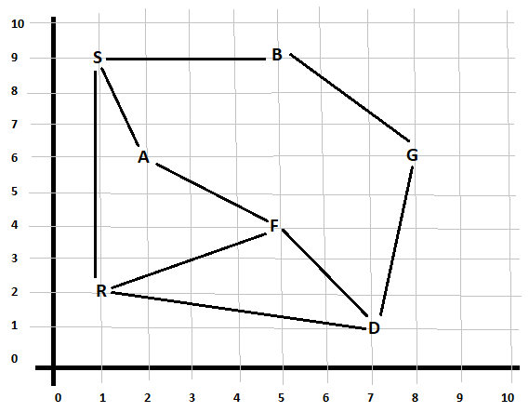

1. **Write Hill Climbing Algorithm. (Write generic algorithm).**